**File:** **Lili_Kokalova_22_e0ea9c.rb**

Task:

Develop a program named FirstName_LastName_ClassNumber_e0ea9c.rb

1. you are given two arguments for a folders with files;

1.1 if there are other arguments they should be discarded;

2. file names in this folders are in the form First_Last_digits.rb;

3. find the students that are only in the second folder and not in the first. A student is in both folders if it there is a file with the same First and Last Name. Digits might be different;

4. Sort the result by First name ;

5. Produce a result in CSV format named result.csv:

LastName1,FirstName1

LastName2,FirstName2

...

LastNameN,FirstNameN

Code:

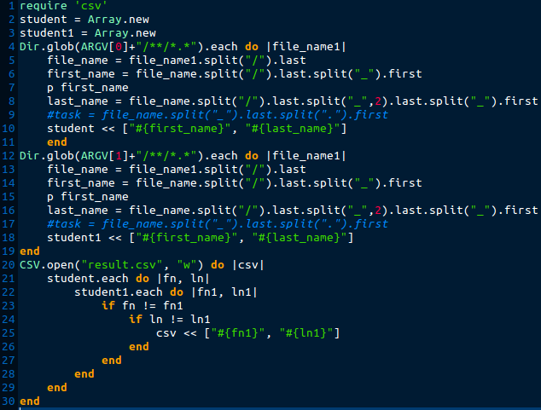

Errors:

* Program print some result in terminal
* In CSV first must be last name instead first name
* In CSV secound must be first name instead last name
* CSV file is not sorted

New code:

